**UGANDA CERTIFICATE OF EDUCATION**

**SENIOR THREE**

**HISTORY AND POLITICAL EDUCATION 241/1**

**TIME: 2 HOURS: 15 MINUTES**

**Instructions to learners**

* This paper consist of section A and B. It has four examination items
* Section A is compulsory
* Attempt one item from section B
* Any additional item answered will not be scored
* All answers must me written in the items booklet provided

Section A:

Attempt all items in this section

ITEM 1

In areas of Kasese in Uganda, river Nyamwamba flooded and very many properties were destroyed including houses, gardens, small scale industries while many of the people surrounding the river were left dead. A few who survived were relocated to neighbouring districts. The children of those who died are cautiously asking themselves many questions regarding the origins of their parents and relatives and have failed to get clear responses.

**Support material:** *Flooding of River Nyamwamba in May 2013*.

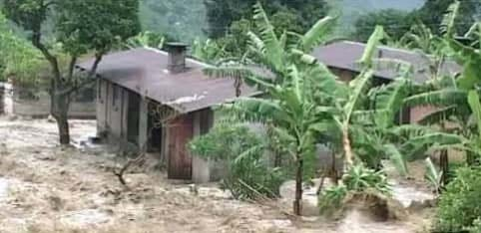

**Task:**

1. Explain to the above children the steps they should follow to achieve their desires.

**ITEM 2**

In Kilembe district, a group of foreign migrants settled in the area and took up the leadership of this district; they subjected the natives to unjust treatment which led them to untold misery and suffering. The natives would like to regain their independence as it is the only way this unfairness can be solved. You have been identified to educate these natives.

**Support material*:*** *A group of foreigners who have invaded an African community.*

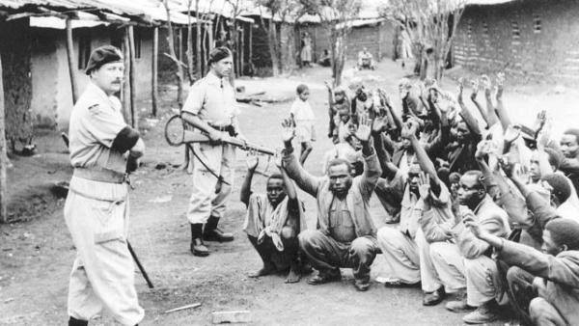

**Task:**

1. Explain ways how they can restore their status.

**SECTION B**

**ITEM 3**

The constitution of Uganda of 1997 allowed the central government to decentralize its powers to the local government. Today the local government is operating in the different districts all over the country. A number of challenges e.g. limited funds; corruption, delay of payments, lack of materials, etc have hindered their work.

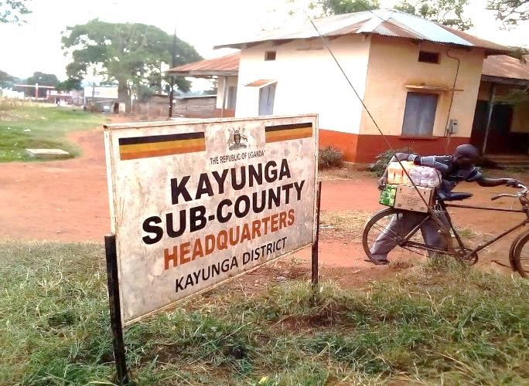

**Task:**

1. What should be done to address the above challenges?

ITEM 4

In Uganda, a recent survey revealed a significant lack of awareness among citizens about their constitutional rights, especially in preparation for the upcoming general elections. In response, a dedicated group of educators is organizing a nation-wide awareness campaign. This campaign aims to empower individuals by increasing their understanding of constitutional rights, and you have been tasked with participating in this important initiative.

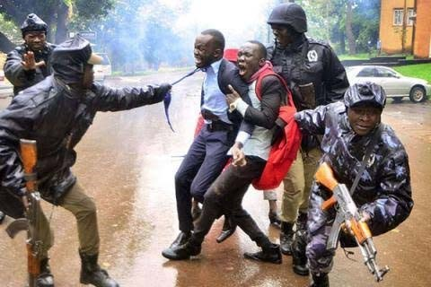

**Task:**

1. Write an essay with key aspects to educate the people in the above nation-wide campaigns.

**END**